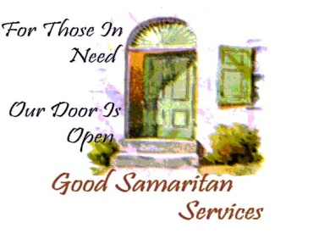
GOOD SAMARITAN SHELTER SERVICES, INC

Application for House Membership

- Santa Maria Women’s CSL
- Lompoc Hope House CSL
- Recovery Point Acute Care Detox
- Santa Maria Men’s CSL
- Lompoc Perinatal
- Santa Maria TC House
- Lompoc Detox
- Recovery Point Acute Care Detox
- Santa Maria F.S.

By execution of this application, I hereby apply for membership in the Good Samaritan Shelter Services, Inc. house as indicated above, and I provide the following information for use by house managers and the staff or agents of Good Samaritan Shelter Services, Inc., for purposes of determining my eligibility and suitability for residential house membership. In order for your application to be considered, the application must be filled out completely. Failure to complete the application may cause you loose your place on the list for availability in the house. Type or print your information. Use additional sheets if necessary.

NAME:__________________________________________________________________________
(last) (first) (middle)
Date of Birth:____/____/____ Sex: Male Female

Social Security No.:____________________ Drivers License No.:______________________

Phone/home:______________ Work:______________ Cell:_______________________

Are you currently homeless/without a permanent place to live? ____ yes ____ no

Current address: ___________________________________________________________________
(street) (city) (state) (zip code)
Are you a recovering:
_______ alcoholic ______ Drug addict Your sobriety date: ____________________

If you have been in substance abuse treatment, either in-patient or out-patient within the last three (3) years, give the name of each program (Detox, treatment center, halfway house, etc.) the dates you attended and the reason for leaving.

___________________________________________________________________________________________________________________________________________________________________________________________________________________________________________________
Are you on Probation/Parole? Yes/No
Name of P.O. ______________________Phone #________________________________

Are you currently in a self-help recovery program, i.e. AA or NA? ____ yes ____ no

How many meetings do you attend per week: _____________

Group/meeting name day/night of week location of meeting/group

Do you have a sponsor: ______yes ______no If no, why not?______________________

What is your current source of income? __ employment ___ disability ___ other

What is your current income per month? Amount $____________

If “other” income is checked, please explain: ___________________________________

Employers Information: ___________________________________________________

Employers Telephone: ________________________

Job/Position: ____________________ Net income amount $ ______________________

Have you applied for:

__ General relief __ Disability __ Unemployment __ Workers compensation

List all other sources of income: ________________________________________________________________________________________________________________________________________________

Do you have children? ____ yes ___ no

If yes, please complete the following information:

Childs name: ________________________ Date of birth: ________________________
Who has custody: _________________________________________________________

Childs name: ________________________ Date of birth: ________________________
Who has custody: _________________________________________________________

Do you have a CWS case? Yes/No
Name of CWS Worker________________________Phone#_______________________

Are you on Medication(s)? Yes/No
If so, what kind?__________________________________________________________
For what purpose?_________________________________________________________

Have you ever been in trouble with the law for battery, arson or any other violent crime?
Yes/No If so, what____________________________when_______________________

Signature Date

